**CHOUCAS BLANC**

Chalet Choucas Blanc is an exclusive property in a luxury residence, ideally situated right in the centre of Val D'Isere. The chalet sleeps 6 adults and up to 2 children

On the first floor, this luxury chalet provides accommodation that is spacious, soothing and intimate. At more than 160m2 plus 2 generous balconies, the chalet is generously sized and the abundance of large windows lets light flood in throughout the day. The décor and furnishing is designed and completed to the highest standard by a highly regarded London based interior designer

Guests of the Choucas Blanc will delight in full breakfasts, afternoon tea and cakes and 4 course evening meals with wine, beer and soft drinks

Located on the Avenue Olympique, Val D'Isere's main high street and a 4 minute walk from the slopes, you really couldn't pick a better spot!

The chalets prime location gives easy access to the many facilities the resort has to offer. The chalet is a 250 metres walk to the Solaise nursery slopes, the closest free bus stop which accesses all major resort lifts is 50 metres from the front of the Choucas building

**The Chalet**

Chalet Choucas Blanc is an exclusive property in a luxury residence, ideally situated right in the heart of Val D'Isere between the resort’s 2 central roundabouts. The village facilities, a fantastic choice of restaurants, bars and shops are immediately outside the Choucas building. From the balconies at the front (south facing) and back (north facing) you will also enjoy breath-taking views of both the famous Val d′Isere mountains and the resort itself.

On the first floor, this luxury chalet provides accommodation that is spacious, soothing and intimate. The décor and furnishing is designed and completed to the highest standard by a highly regarded London based interior designer

The entrance hall includes cupboards with individual baskets for your helmets, gloves socks, snoods, woolly hats….

From the entrance hall you come straight into the grand open plan lounge, dining, kitchen area. At almost 100m2, this is undoubtedly one of the biggest living spaces in Val D’Isere complete with a generous dining table to seat 8 people and a sumptuous lounge area with a wide choice of comfy seating

The lounge includes a roaring log fire which our chalet hosts will be delighted to set up for you (to comply with building regulations). From the balcony you can directly access the front balcony to soak up the sunshine and see skiers and snowboarders on the famous Face de Bellevarde Olympic downhill or watch life passing on the village street below

The Smart TV allows access to most UK channels and the major streaming services. The chalet is fitted with WiFi and boosters to ensure a strong signal throughout

The fully equipped kitchen where out hosts will prepare all meals includes a huge breakfast bar with 4 high stools. The corridor contains ample storage space

Heading down the corridor to the bedrooms, there is a spare shower / toilet room which also serves as the laundry and there is sleeping space for 6 adults and up to 2 children. All bedrooms have en suite facilities (2 with baths and 1 with a shower). The bedrooms also share a generous balcony which looks to the mountains to the opposite side to the ski area

To complete your stay, the ground floor of the Choucas residence includes a ski locker with shoe warmers (please note all skis, snowboards, boots must be kept in the ski lockers) for up to 8 people and the basement has a garage with space for your vehicle

**Sleeping arrangements**

The bedrooms are on the back of the chalet so you wont be disturbed

1 x Master bedroom with double (180cms bed) and en-suite bathroom with hairdryer and toiletries

1 x Second bedroom with double (180cms bed) or twin beds and en-suite shower room with hairdryer and toiletries

The second bedroom has an adjoining kids bedroom with bunk beds (suitable for children aged 12 and under)

1 x Double bedroom with (180cms bed) and en-suite bathroom with hairdryer and toiletries

**Inclusive Board Basis**

7 nights accommodation in our beautiful chalet

All catering provided by our dedicated English speaking chalet team, in the chalet

Full daily continental breakfast service for 7 days of the holiday plus hot food cooked to order - eggs, omelette, full English on 6 of the days

Afternoon tea / coffee and freshly baked cake / muffins / cookies

4 course dinner with French / Savoyard wines on 6 of the nights (Wednesday off). Our staff prepare a well balanced menu but will agree the specific menu for your week with you prior to your arrival - sample menu

Fresh and fully stocked fruit bowl

Daily cleaning and making beds

French lager and  a selection of soft drinks in the fridge are provide free of charge

Towels (with midweek change), dressing gowns and bed linen

Roaring log fire – please ask our chalet hosts to set this up for you (according to local regulations)

Our staff know the chalet and have been to Val D'Isere countless times so are well placed to provide advice on the ski area, the restaurants and the resort in general

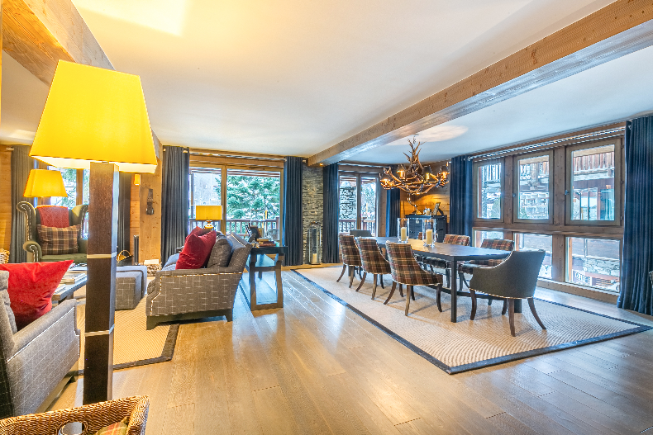

Dining Room

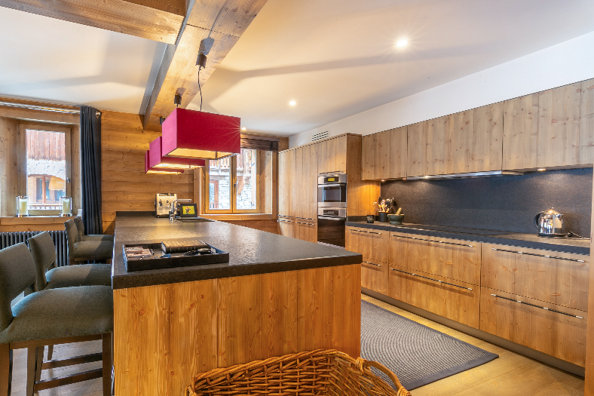

Kitchen



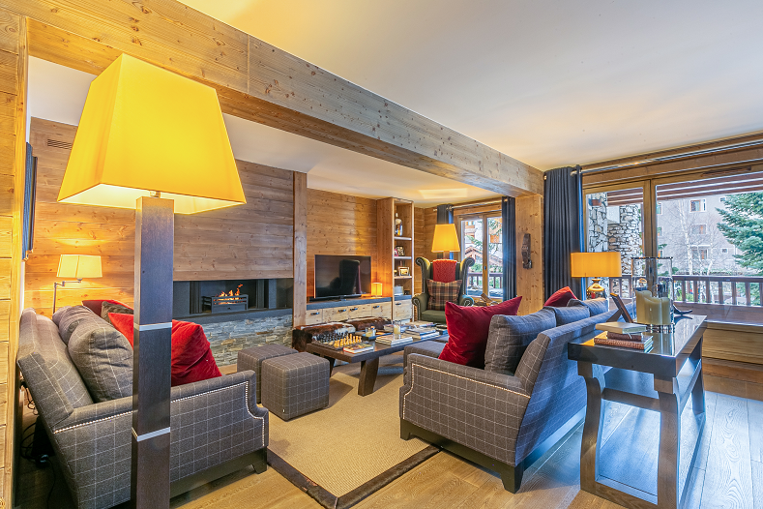

Lounge

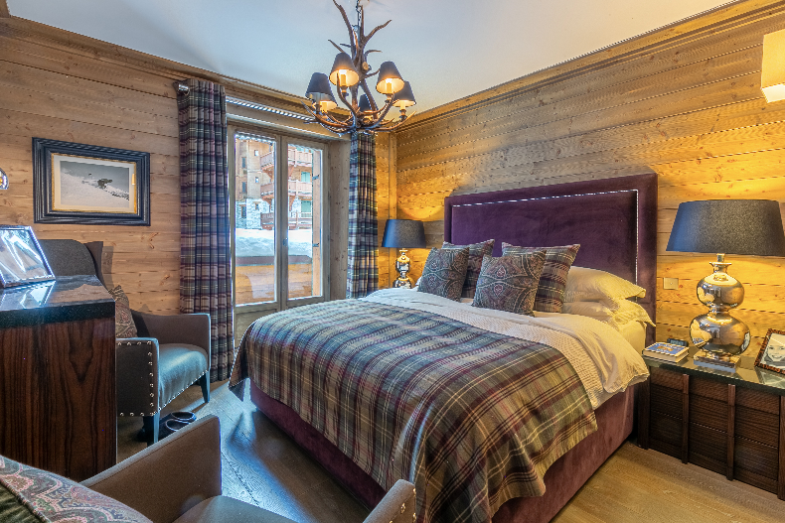

Master Bed

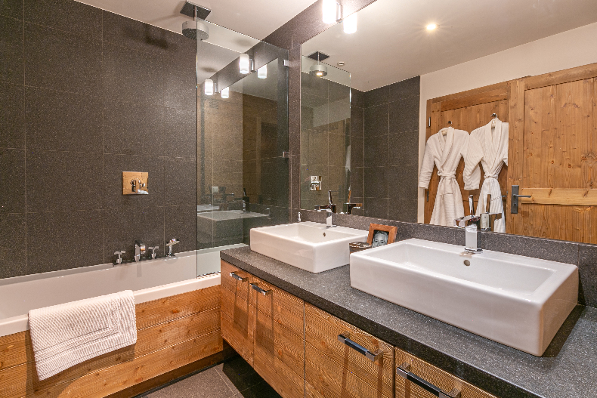

Master Bath

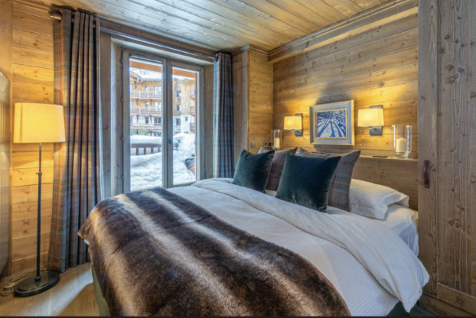

Bedroom 2

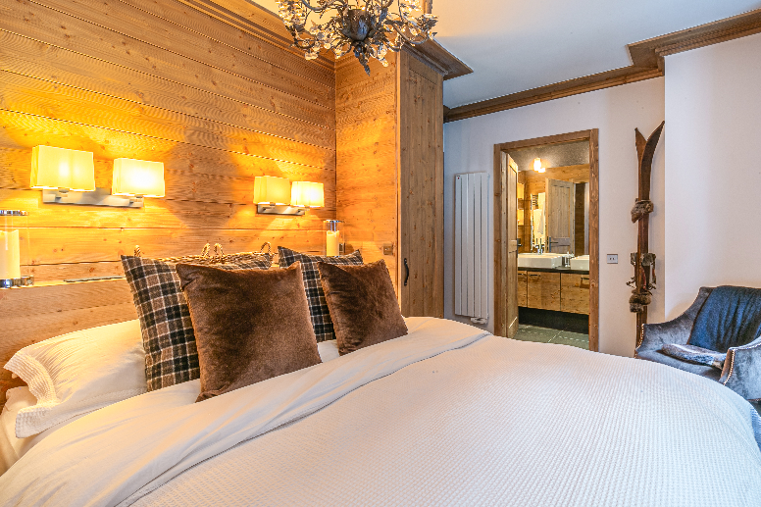

Bedroom 3

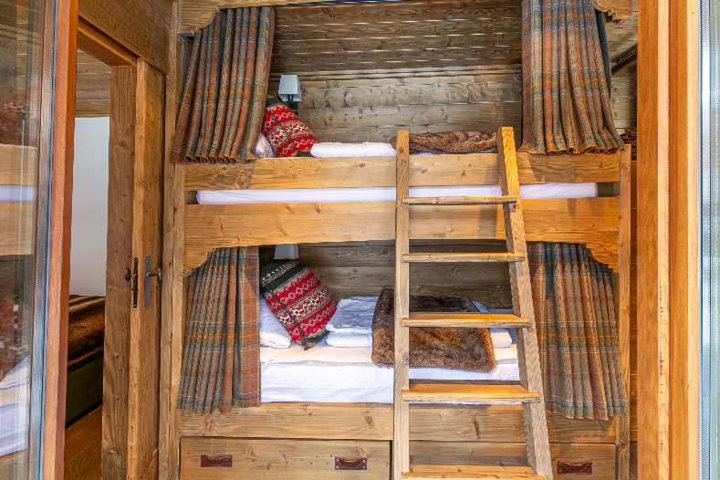

Bunk room

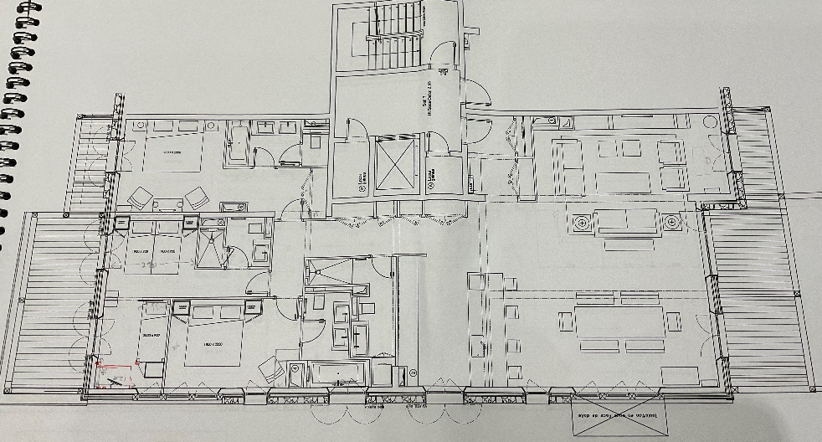

Floor Plan

**Pricing & Availability**

**Dec 7th         £1285          AVAILABLE**

**Dec 14th      £1550          SOLD OUT**

**Dec 21st       £2633          AVAILABLE**

**Dec 28th      £3297          AVAILABLE**

**Jan 4th         £1728          SOLD OUT**

**Jan 11th      £1597          AVAILABLE**

**Jan 18th      £1597          AVAILABLE**

**Jan 25th      £1897          AVAILABLE**

**Feb 1st         £2124           AVAILABLE**

**Feb 8th        £2292           AVAILABLE**

**Feb 15th     £3417            ENQUIRE**

**Feb 22nd    £2097            ENQUIRE**

**Mar 1st        £1875            AVAILABLE**

**Mar 8th       £1779            AVAILABLE**

**Mar 15th     £1779           SOLD OUT**

**Mar 22nd    £1945           AVAILABLE**

**Mar 29th     £2500           AVAILABLE**

**Apr 5th        £2475           AVAILABLE**

**Apr 12th      £1745           SOLD OUT**

**Apr 19th      £1489           SOLD OUT**

All prices are in GBP for 7 nights catered chalet board and are per person based on 6 adults sharing. Where 6 adults share, up to 2 children (under 12 years) can stay free of charge

A deposit of 25% is payable to reserve your stay, final balances are due 8 weeks prior to travel. A security deposit of £1000 per booking is also payable with the final balance - this will be repaid to you within 7 days of your departure from resort

Should you wish to book flights, private transfers, ski passes, ski hire, ski school, insurance etc please contact us as our sister company can organise this for you

**Contact us**

Telephone: +44 7767 366520

E-mail: [choucasblanc@hotmail.com](mailto:email@example.com)

[www.choucasblanc.com/booking-request](http://www.choucasblanc.com/booking-request)

Address: Chalet Choucas Blanc, Avenue d'Olympique, Val D'Isere, 73150, Savoie, France